STREET LIGHTING ENERGY SAVING SCHEME

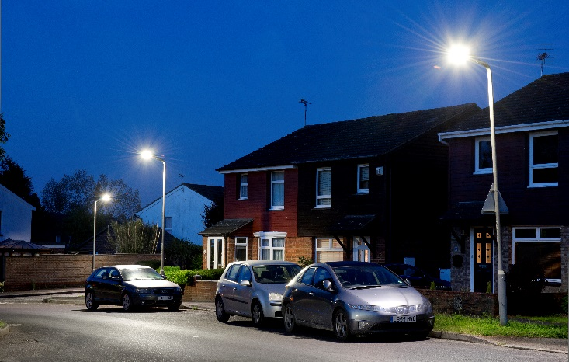
Kent County Council

CLIENT’S REQUIREMENTS
In 2015 Bouygues Energies & Services (BYES) partnered with Kent County Council (KCC) to reduce street lighting energy consumption.
The council wanted to reduce consumption by at least 60% whilst maintaining lighting standards in accordance with BS5489:2013.

BOUYGUES ENERGIES & SERVICES SOLUTIONS
We delivered a design solution that guarantees KCC energy savings, driving down Council costs, achieving the greenhouse gas emissions reduction targets, and increasing overall efficiency.

Work to install LED lanterns started in March 2016 and the project delivery followed in three phases:
- In the first 14 months, 75,000 residential street lights were changed
- Over the next 24 months 45,000 major road and town centre street lights were changed
- Ongoing maintenance of the assets extends for the duration of the contract (15 years).
Working together, BYES and KCC exceeded the savings target, and are now achieving 67.7% energy savings (an additional £667,000/year)
Annual consumption is just 14,472,030 kWh, giving total annual energy savings of £5.9 million. Carbon Reduction Commitment savings add £262,562.
To ensure ease of monitoring, all the newly installed units are linked to a dynamic central management system (CMS) which allows KCC to manage and adapt lighting levels as required.
Bouygues’ installation crews and mobile supervisors ensure safety, efficiency, productivity and quality. We completed conversion of all streetlights to LED on schedule in 2019.

CLIENT BENEFITS
GUARANTEED SAVING
Kent County Council’s investment is guaranteed by the underwriting of energy and maintenance savings.
ENERGY AND CARBON SAVING
The conversions save Kent County Council over £6m a year in electricity and carbon.
SATISFIED RESIDENTS
Residents give favourable feedback - improved lighting makes them feel safer and benefits the night time economy.
ACCELERATED INSTALLATION
A ‘smart logistics’ approach enabled an accelerated programme option.
MAINTENANCE REDUCTION
Annual maintenance costs are reduced.
KEY FIGURES

£6 million a year energy/carbon savings
- 75% of County’s 2020 greenhouse gas emission target
- 120,000 street lighting assets upgraded
- 15 year maintenance contract

www.bouygues-es.co.uk businessdevelopment.infra@bouygues-es.co.uk

